Create deployment

apiVersion: apps/v1  
kind: Deployment  
metadata:  
 name: hpa-deploy  
spec:  
 replicas: 1  
 selector:  
 matchLabels:  
 app: nginx  
 template:  
 metadata:  
 labels:  
 app: nginx  
 spec:  
 containers:  
 - name: nginx  
 image: amitow/nginx:v1  
 resources:  
 requests:  
 cpu: "25m"  
 limits:  
 cpu: "200m"

**Step 2: Create a Service**

Create a file named nginx-service.yaml with the following content:

apiVersion: v1  
kind: Service  
metadata:  
 name: nginx-svc  
 labels:  
 app: nginx  
spec:  
 ports:  
 - port: 80  
 selector:  
 app: nginx

Create HPA

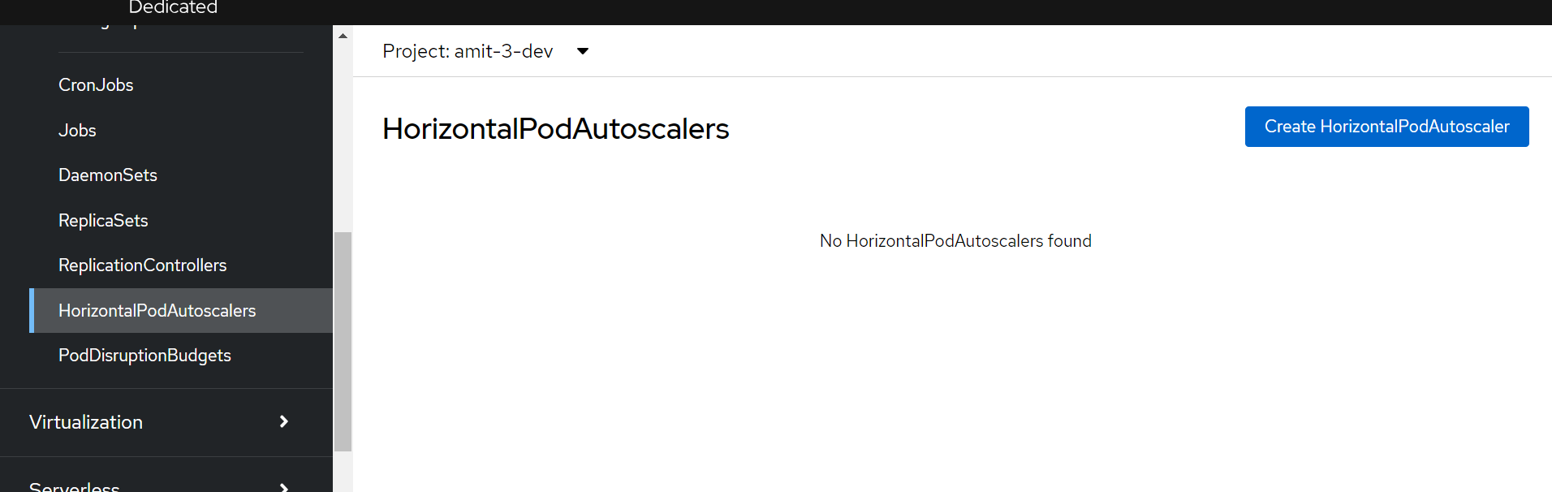

apiVersion: autoscaling/v2  
kind: HorizontalPodAutoscaler  
metadata:  
 name: nginx-hpa  
spec:  
 scaleTargetRef:  
 apiVersion: apps/v1  
 kind: Deployment  
 name: hpa-deploy  
 minReplicas: 1  
 maxReplicas: 10  
 metrics:  
 - type: Resource  
 resource:  
 name: cpu  
 target:  
 type: Utilization  
 averageUtilization: 50

Pod status before generate load:

$ kubectl top po